**Report Definition:**

**Purpose of Report Definition:**

* **It will retrieve the Data from table & Display data ( View)**
* **Report Definition is alternate Rule to Obj-Browse Method**
* **Report Definition is created under Data Class( Ex: States Tables)**
* **Report Definition created under Reports Category**
* **To Fetch Records & Display Records, PRPC Executes a built in API/Activity ( pxRetrieveReportData) in the background**

**Report Definition Provides below OOTB features.**

* **Fetch Data + display the Data.**
* **Export the data to PDF or Excel.**
* **Data can be displayed like Chart.**
* **Report Definition Rule can be called as a source to Dropdown &It can be called in sections using Table Layout**

**Which is Best Practice Obj-Browse/Report Definition**

**Ans: Report Definition ( It is Using Predefined API)**

**===**

**Req: Populating Values for State dropdown from States Table using Report Definition Rule:**

**Create Report Definition under States Table Data Class:**

**Add States Table to Pinned Classes:**

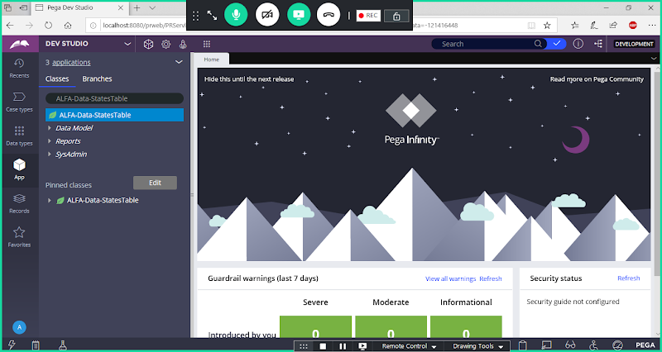

**Create Report Definition:**

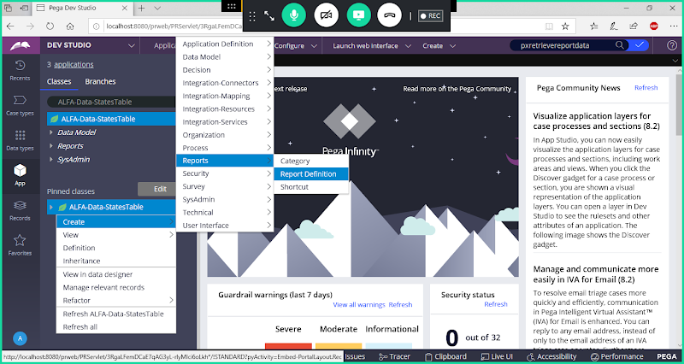

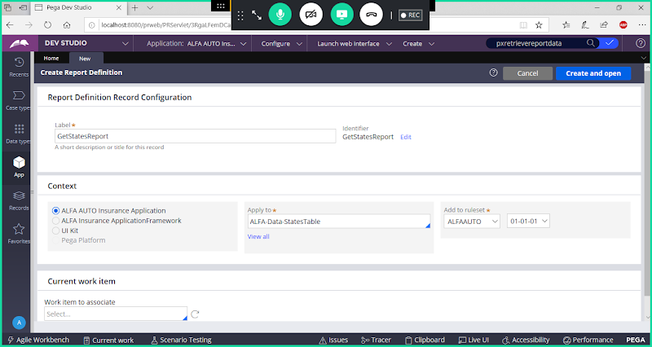

**Open**

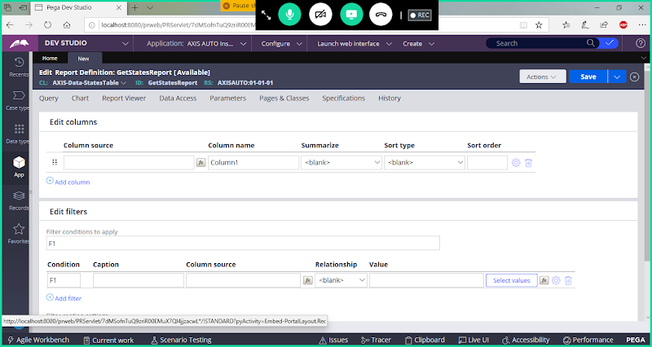

**Add Column Source:( Properties)**

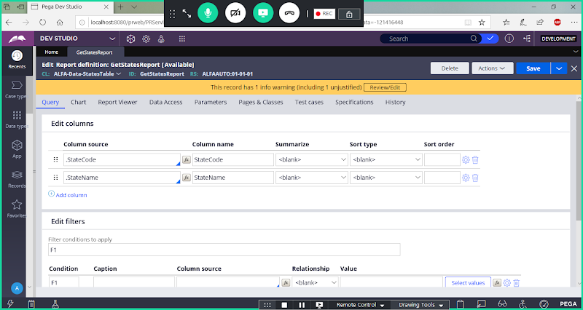

**Save Report Definition**

**Run Report Definition**

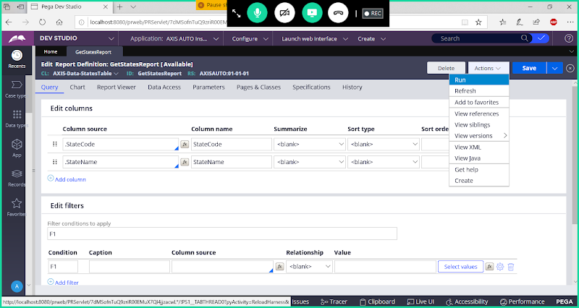

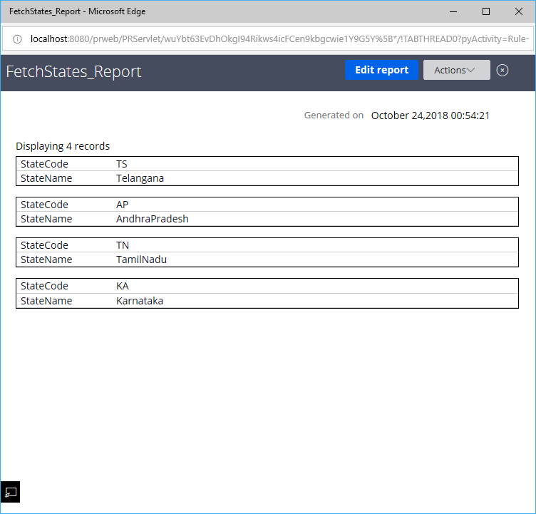

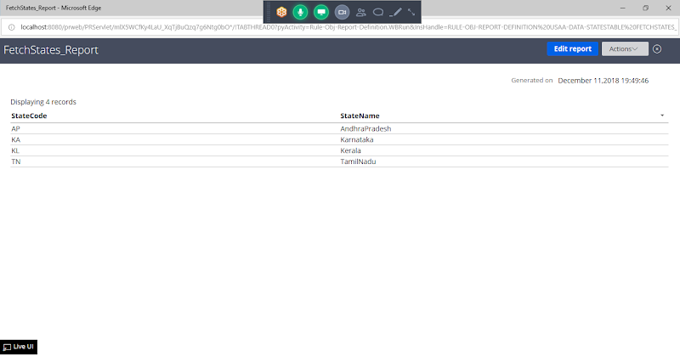

**Call Report Definition Rule under State Property by Replacing Clipboard Pages:**

**Select List Source Type as Report Definition**

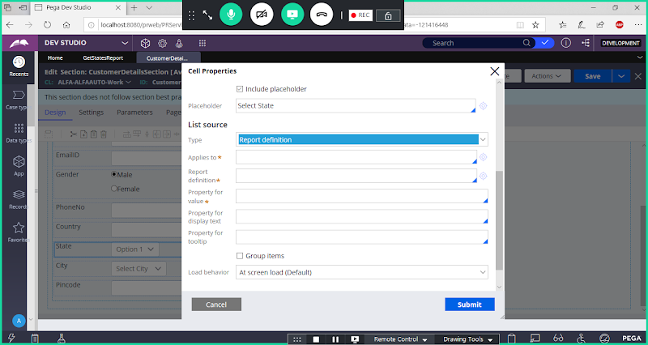

**Now Add Table Name & Report Definition Rule Name**

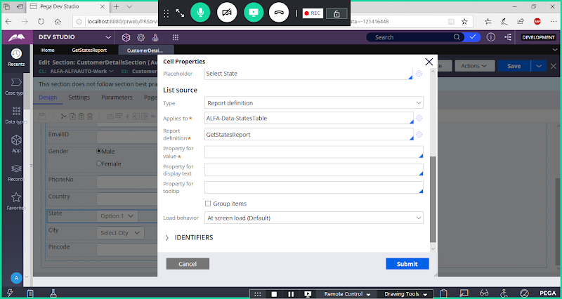

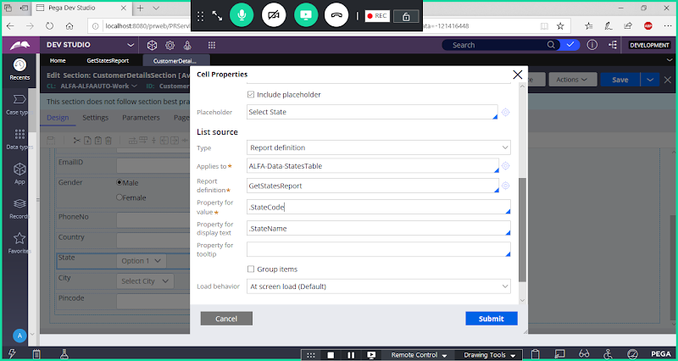

**Submit & Save section**

**Open Customer Flow & Run the Flow**

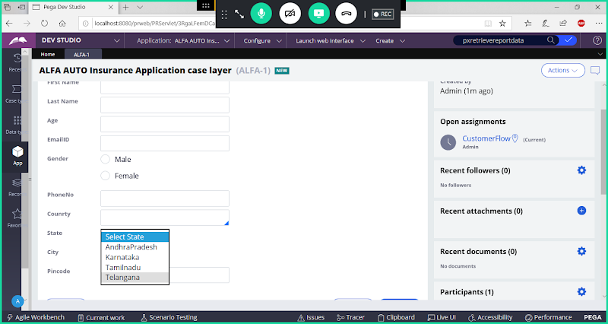

**===========================**

**Diff B/w Obj-Browse & Report Definition?**

**Obj-Browse:**

* **Using Obj-Browse We can Fetch Multiple Records**
* **Obj-Browse is a Method.**
* **Obj-Browse will only Fetch Records but Not Display**
* **For any Method if alternate rules are there we have to go for alternate functionality ( Rule/API)**
* **Fetch & Other Actions if you want to Perform then go for Activity Only**

**Report Definition:**

* **Using Report Definition We can Fetch Multiple Records**
* **Report Definition will be using API ( Predefined Activity ) - pxRetrieveReportData to Fetch & Display Records**
* **Report Definition will Fetch & Display Records( View)**
* **In Report Definition we cannot perform other Actions ( Insert/Update/Delete)**
* **Comparing Obj-Browse & Report Definition , Report Definition is Best Practice.( When Performing only Fetch Action)**